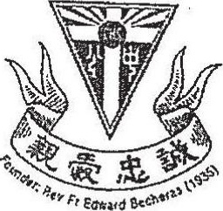

CATHOLIC HIGH SCHOOL  
VID-YEAR EXAMINATION (2049)  
PRIMARY SIX  
ENGLISH LANGUAGE

PAPER 2 (LANGUAGE USE AND COMPREHENSION)  
BOOKLET A

Name: et )

Class: Primary Six _________

13 May 2019

23 Questions  
(28 Marks)

Total Time for Booklets A and B: 1 hour 50 minutes

INSTRUCTIONS TO CANDIDATES  
  
Do not open this booklet until you are told ta do so.  
Follow all instructions caretully.  
  
Answer all questions.

This booklet consists of 8 printed Pages excluding the cover page.